**Part 2 Comments**

* I understand that this part will be changed to show just one optimised Beta, right?

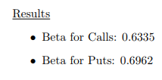

* Increase chart font size for all charts, make them shorter and longer to conserve more vertical space
* Remove chart titles since they are already titled as Figure 1,2 etc anyways

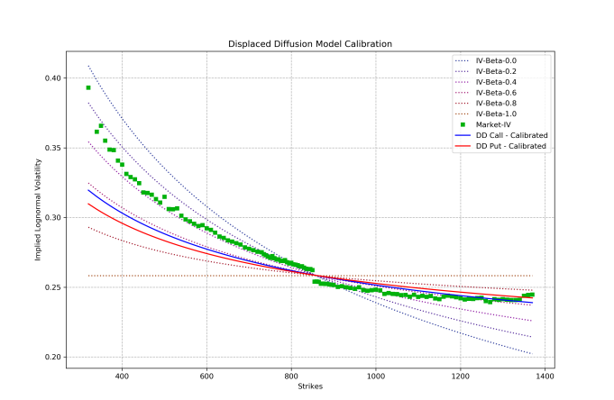

* Let’s standardise to have \noindent for our paragraphs
* “model with resulting implied volatilities plotted as “Market-IV”.”



* “lines can be seen in the chart **above”**



* Include additional sentence which sets the stage for the justification of the use of the SABR model



* Colour scheme is amazing, you are right on this one, needs to be made bigger in order to be visible
* Use expanded margins in the working LaTeX file, increase chart font size and reduce space between charts
* If still unviable, better to stack them vertically instead and have commentary on the right-hand side as a mini page